STIs assessment – Science Inquiry Skills Name _________________________
10% of yearly grade

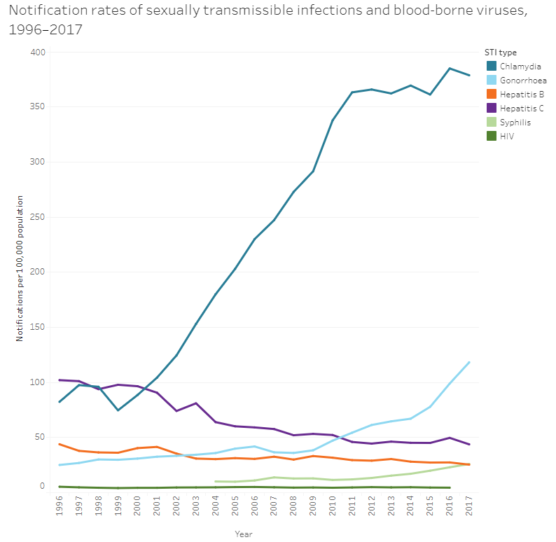

Using data from the graph, what was the percentage increase in Chlamydia infections from 1999 to 2017? Show your working (3 marks)

Using the graph, calculate the increase in rate per year from 2003-2009 (hint – rise over run) (2 marks)

Notification rates of selected sexually transmitted diseases, Australia, 2013–2017
Notifiable disease | 2013 | 2014 | 2015 | 2016 | 2017
Gonorrhoea | 64.4 | 66.8 | 77.6 | 98.7 | 93.7
Genital Herpes | 124.6 | 128.8 | 143.6 | 142.3 | 147.0
Chlamydia | 362.0 | 369.3 | 352.5 | 371.5 | 312.0

List three other STIs, one bacteria, virus and parasite, that are not represented in this table (3 marks)

Using the table, create a graph comparing the rates of notification of the three STIs in 2017. (5 marks)



The questions on the following page refer to the graph and table on this page.
Below is a graph outlining the rate of Chlamydia infections in the US.
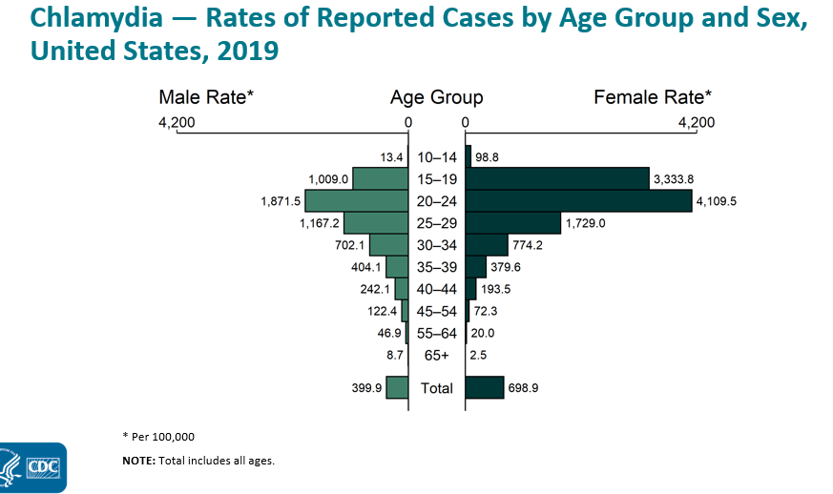

Below is a table outlining the same set of data but for Gonorrhoea.
Year | Age Group | Sex | Rate |  | Year | Age Group | Sex | Rate
2019 | 10–14 | Female | 20.7 |  | 2019 | 10–14 | Male | 4.9
2019 | 15–19 | Female | 559.5 |  | 2019 | 15–19 | Male | 328.6
2019 | 20–24 | Female | 737.4 |  | 2019 | 20–24 | Male | 743.5
2019 | 25–29 | Female | 444.1 |  | 2019 | 25–29 | Male | 700.6
2019 | 30–34 | Female | 265.4 |  | 2019 | 30–34 | Male | 524.9
2019 | 35–39 | Female | 154.2 |  | 2019 | 35–39 | Male | 341.7
2019 | 40–44 | Female | 84.9 |  | 2019 | 40–44 | Male | 223.2
2019 | 45–54 | Female | 32.6 |  | 2019 | 45–54 | Male | 128.3
2019 | 55–64 | Female | 8.8 |  | 2019 | 55–64 | Male | 57.3
2019 | 65+ | Female | 1.2 |  | 2019 | 65+ | Male | 10.1
2019 | Total | Female | 152.6 |  | 2019 | Total | Male | 224.4

- Using data from the previous page, outline the differences between chlamydia and gonorrhoea on the basis of: (8 marks)
- Sex

- Overall rate of infection

- Infections in the 15-19 age group

- Infections in the 25-29 age group

- What type of graph is this? ____________________________ (1 mark)

- What do these two types of infections have in common? (2 marks)

- Although the rates of chlamydia may be higher, why may gonorrhoea infections be more of a concern? (1 mark)

- Give two possible reasons, other than higher rates of infection, that may have caused higher rates of detection/reporting of Chlamydia in females rather than males. (2 marks)

- The rate is based on number of cases per 100,000. How many males aged 15-19 would be expected to be diagnosed with gonorrhoea in a city with 20,000 people? Show your working (3 marks)

